- From today on, after entering the booth and having your body temperature checked with the result that the body temperature is normal, please follow the staffs’ instruction and touch your student/staff ID card on the card reading machine so to keep the data recorded.
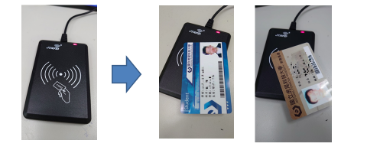

- Lost/Forget your card? Have your ID number recorded by staffs, and enter campus buildings with paper pass. (with the stamp on it showing the entrance date)

- Visitors: All visitors must fill in the questionnaire, and enter campus buildings with paper pass. (with the stamp on it showing the entrance date)
From today on, please show your student/staff ID cards before entering all campus buildings
Verification Ways:
- By reading your ID cards.
- By logging into eCare system through your cellphones and show the result to the staffs.

- For visitors and those who have lost their cards: show the formalized pass with entrance date.
